CURRICULUM VITAE

Name :Batool Ahmed Farag Radi

Job : Lecturer

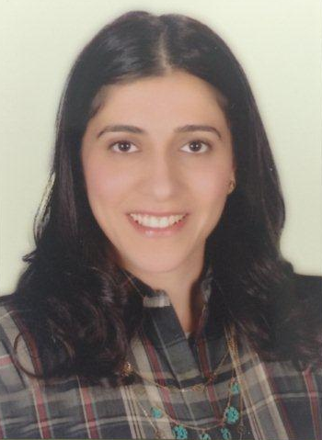

Career objectives:

•Seeking new challenges in Horticulture field which effectively utilizes my professional experience.
•Looking to join a progressive organization that has the need for an Agricultural specialist and offers opportunities for advancement.
•To gain first hand in Horticulture field using my analytical skills and commitment to perform quality work.
Academic Qualifications:

Faculty of Agriculture Assuit- Egypt
Bachelor of Agriculture Horticulture Department (Vegetables) 1999
• Graduation year: 1999

M.Sc. Degree in Agriculture (Horticulture/Vegetables) Assuit-Egypt
Horticulture Department (Vegetables) 2004
Faculty of Agriculture, Assuit University
Date : June 2004

Grade : Excellent
Title of M.Sc. Thesis: Effect of some factors on seed yield and some other characters in Radish (Raphanus sativus L.)

PHD. Degree in Agriculture (Horticulture/Vegetables) Assuit-Egypt
Horticulture Department (Vegetables) 2015
Faculty of Agriculture, Assuit University
Date : January 2015

Grade : Excellent
Title of PHD. Thesis: Performance of some new broad bean genotypes under Assiut conditions

Computer literacy:

Microsoft office
- Internet

PERSONAL DATA:

- Date of birth : 14 Mar. 1979
- Marital status : Married
- Driving license : Valid UAE license
- Mobile phone : +97150-8173309
- E-mail address : b_radi79@hotmail.com
- Nationality : Egyptian

Languages:

- Arabic : Mother Tongue
- English : Very good, Written, spoken and reading

Details of professional Experience:

Faculty of Agriculture, Assuit University, Egypt

Title : Teacher Assistant

Duration : Sept. 1999 ~ June 2003 and Sept. 2010 ~ Sept. 2013

Location : Assuit- Egypt

• Teacher assistant in faculty of Agriculture Horticulture Department (Vegetables) responsible for:

- Participating in lectures and presentations for undergraduate students.
- Practical demonstration in practical sessions and laboratory.
- Participating in conferences held at faculty by papers and researches together with my supervisors.
- Supervision of the cultivation of radish under different circumstances which is the Thesis subject of my masters, taking records and results, preparing histograms.
Traveling:
Lived for 4 years in Yemen and 5 years in U.A.E with shorter periods in France and Germany.

